23rd – 28th July 2020 Gorillas & Wildlife Uganda Group Tour Passenger Booking Form

Please fill out the details below and email back to info@wildtroopers.com
Full Name: (As Per Your Passport)
Email:
Mobile No:
Home Address:
Passport No:
Date of Birth/Age:
Group Tour Name:
Diet requirements:
Emergency contact:
Please indicate if you prefer a single room (extra $250 per person)
Provide Whatsapp number if you would like to join the tour chat group

Notes if Any or Other Travel Requests or Travel Extensions

INVOICE
GROUP TOUR PRICE: USD 1950 per person (Double/twin room sharing)
Details | Payment per person
July 2020 gorillas & Wildlife | $1950
Single room supplement | $0
30% Advance payment | $585
70% Balance payment | $1365

Please make your advance payment as soon as possible. The balance payment must be made 6 weeks prior to your arrival. You can make your payments using any of the below methods:

- Make a transfer to our international US Dollar account (the sender is required to cover all banking costs):
Beneficiary Name: Wildtroopers safaris company limited
Account number: 1036201121493
Bank Name: Equity Bank
Branch: Oasis Mall
Swift Code: EQBLUGKA
City, country: Kampala, Uganda
Description: Gorillas & Wildlife safari July 2020 group tour

- Make a transfer to our US Dollar account with your credit/Debit Visa card (an extra cost of 3.5% of the total sum applies)
Follow this link to make an online payment https://payments.pesapal.com/wildtroopers

23rd – 28th July 2020 Gorillas & Wildlife Group tour detailed itinerary
AT A GLANCE
- Game drives (safaris) on the savannahs of Queen Elizabeth National Park
- See the chimpanzees and 12 other monkey species in Kibale Forest National Park
- Boat trip on the Kazinga Channel with the biggest concentration of hippos and spectacular birds
- Search for the tree climbing lions in the Ishasha sector of the Queen Elizabeth National Park
- Meet the Mountain Gorillas in Mgahinga national park, an experience you will never forget!
- Visit the local people and/or the pygmies and experience their local way of living
- City tour of Kigali visiting the emotional Genocide memorial museum

FB= Breakfast, Lunch & Dinner
BB= Bed & Breakfast

DAY 1 (23rd July 2020) ARRIVAL AT ENTEBBE AIRPORT
Arrival at Entebbe Airport. Pick up and transfer to your accommodation for a much-needed rest.
Overnight: Forest Cottages (BB) dinner not included

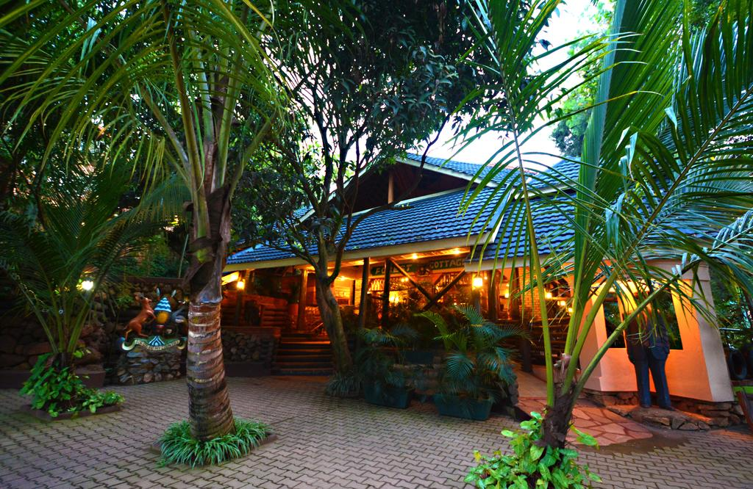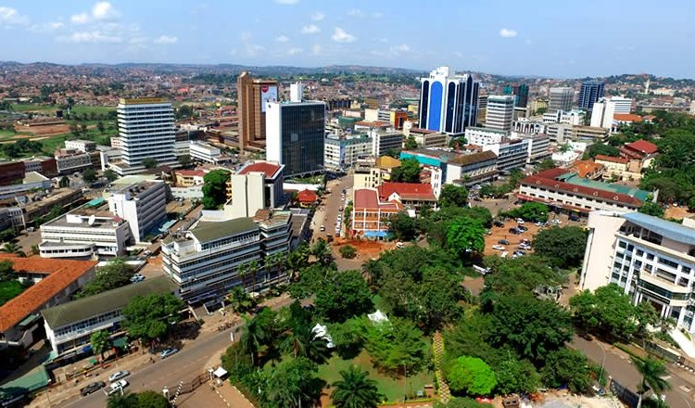

DAY 2 (24th July 2020) KIBALE FOREST
After breakfast we drive to Kibale Forest National Park. Make a walk around the lodge with possibilities of spotting monkeys and different bird species.
Kibale Forest is a spectacular jungle, with 13 primate species! Including chimps, baboons, black and white colobus, red colobus, grey cheeked mangabey and L’Hoest monkey.

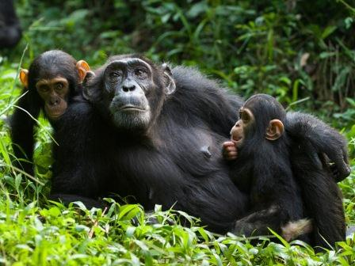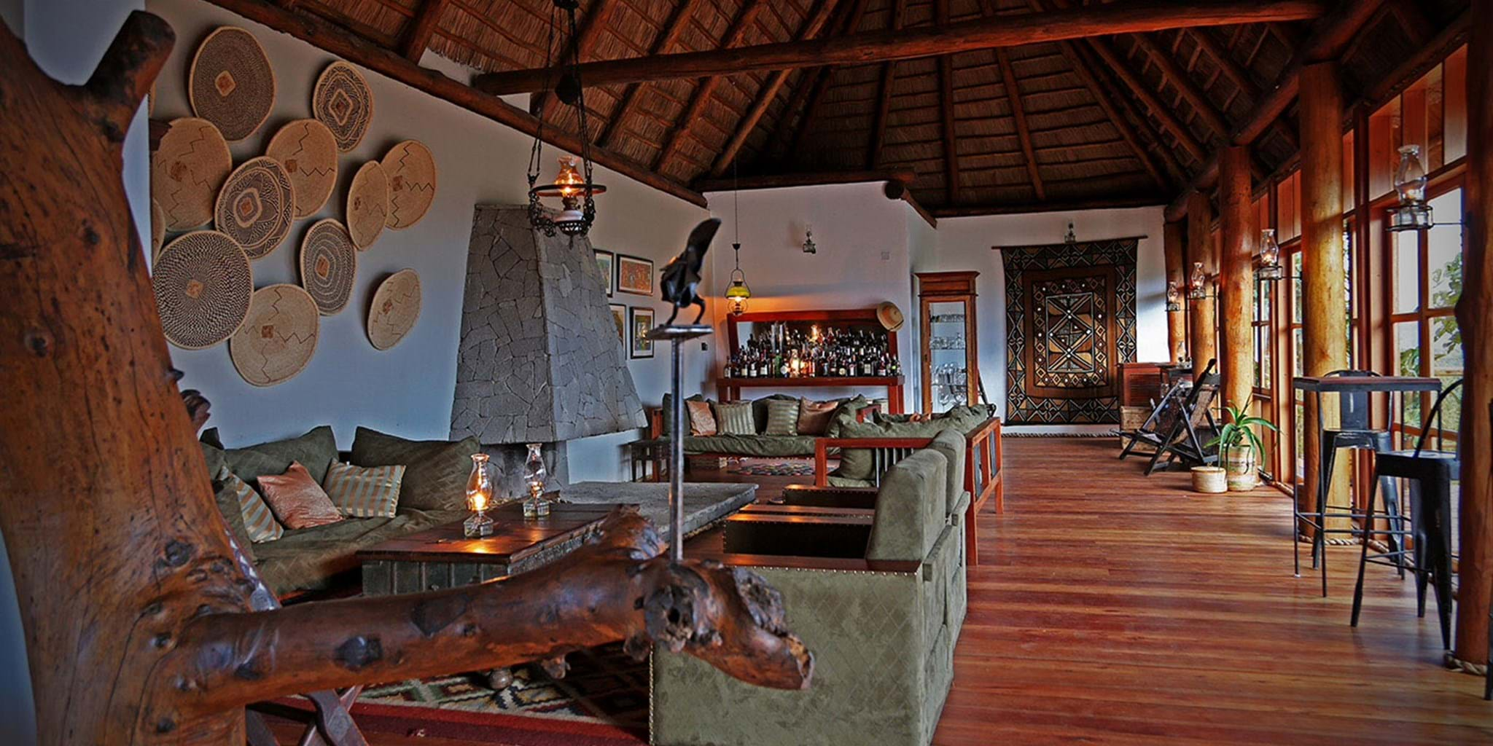
Overnight at Rweteera safari park tents (FB)

DAY 3 (25th July 2020) CHIMPANZEE TRACKING

Chimpanzee tracking in the morning or afternoon (Depends on permit availability). Later we drive to Queen Elizabeth national park for an evening game drive Queen Elizabeth National Park is one of the best places in Uganda to see lions. Expect

to see elephants, lions, many hippos, crocodiles, buffaloes and maybe leopards.

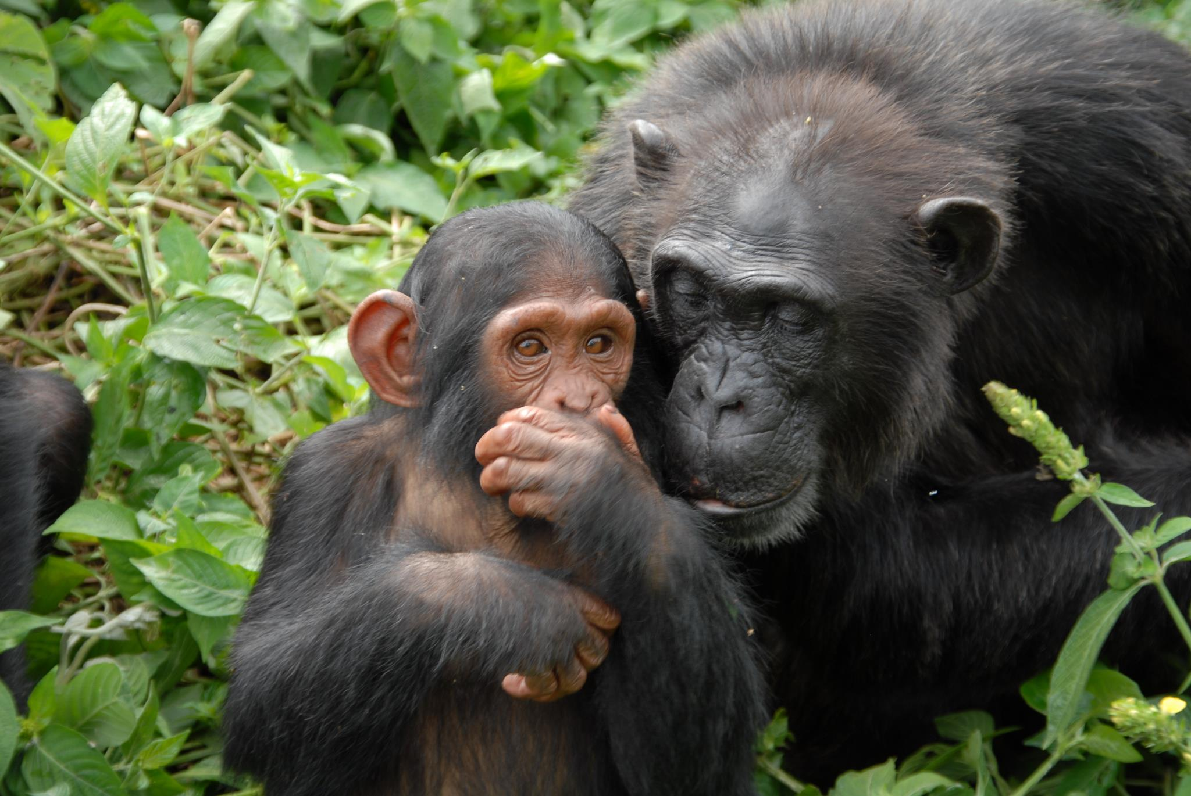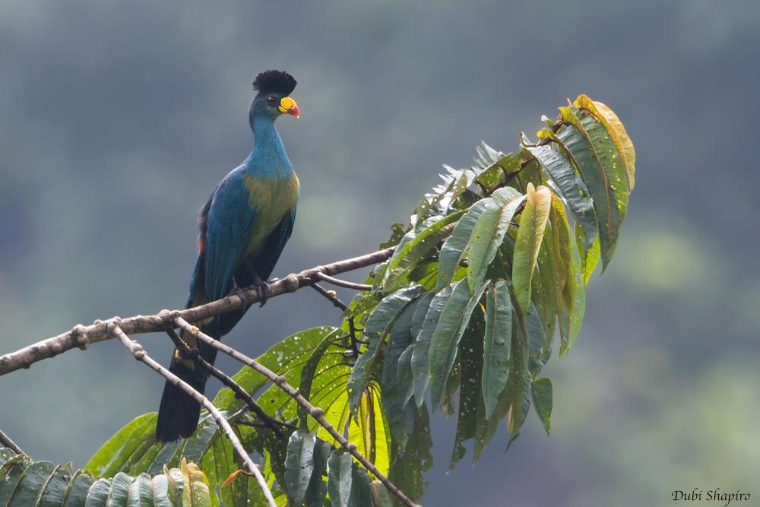
Overnight at Engiri game lodge tents (FB)

DAY 4 (26th July 2020) QUEEN ELIZABETH NTIONAL PARK

Early morning game drive in the park. In the afternoon we go for a boat trip on the Kazinga channel. The Kazinga Channel is one of the highlights of Uganda and has the highest concentration of hippos in the world.

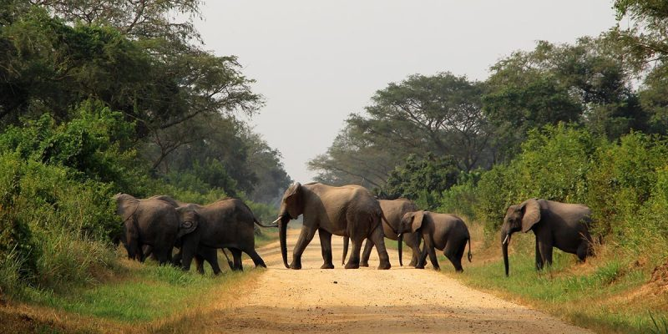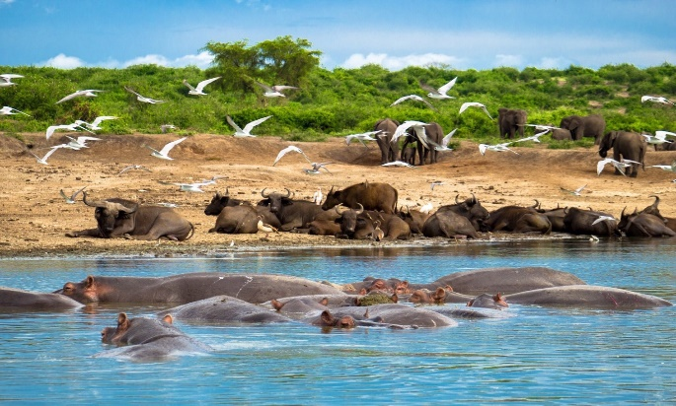
Overnight at Engiri game lodge tents (FB)

DAY 5 (27th July 2020) SEARCH FOR TREE CLIMBING LIONS

Game drive in the Ishasha sector in search of tree climbing lions and later we dive to Mgahinga national park. On our way, we pass through interesting villages and have some breath-taking views of the mountains. We visit the Batwa Pygmy community for a rare cultural experience

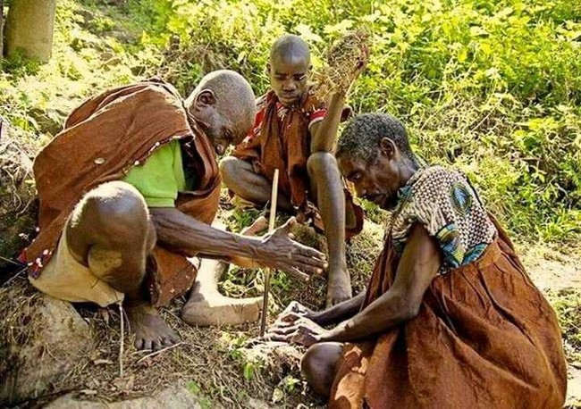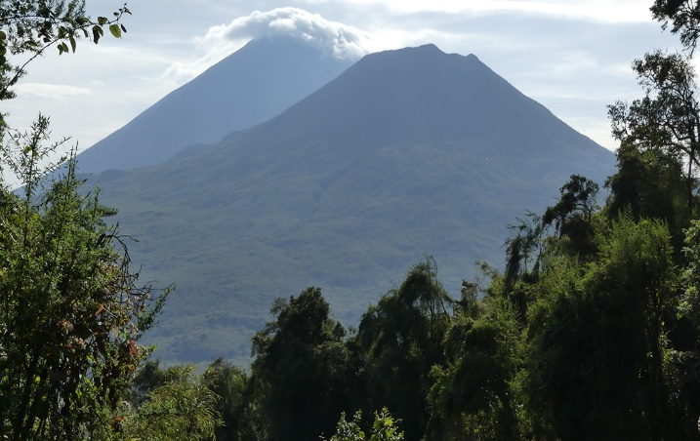
Overnight at Lake Mutanda community camp (FB)

DAY 6 (28th-July-2020) GORILLA TRACKING

Early morning departure with your ranger to search for one of the world’s most interesting and endangered animal, the Mountain Gorilla! You will spend one hour with one of our closest relatives. An experience you will never forget Later we drive to Kigali airport for your departure flight. Kigali city tour and visit of the genocide memorial museum if time allows.

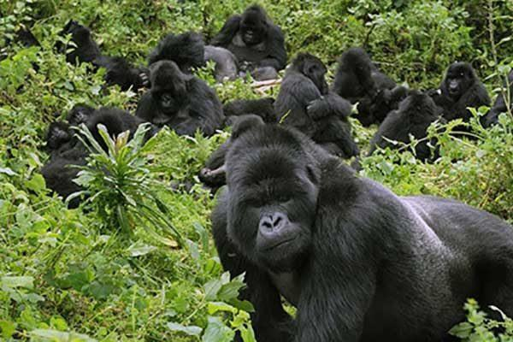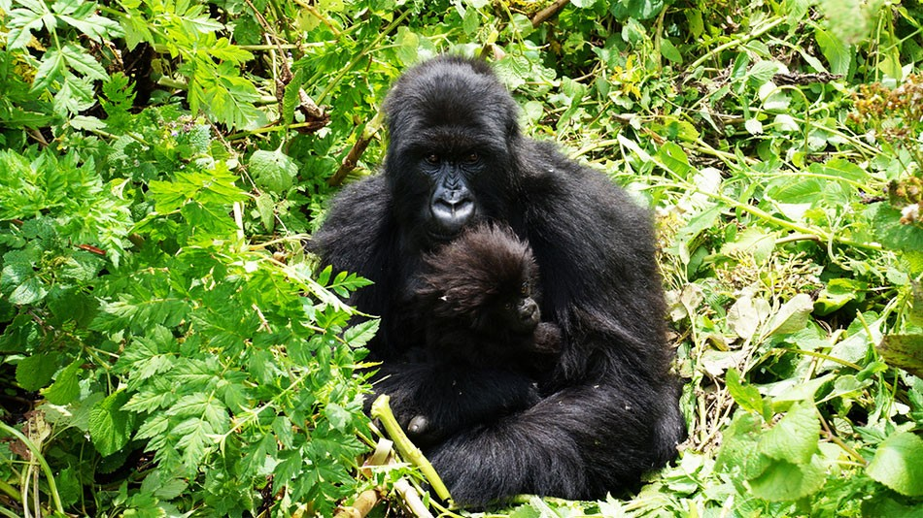
End of Safari
WE ARE LOOKING FORWARD TO HOSTING YOU TO UGANDA!

QUOTATION
USD 1950 per person (twin room sharing)
Options
USD 100 for a single supplement
This Package Includes;
- All Accommodation with Meals mentioned
- All airport transfers
- 4x4 custom-built safari vehicle with knowledgeable driver/guide and fuel
- Bottled drinking water
- One Gorilla tracking & Chimpanzee tracking permit
- One Boat trip on Kazinga Channel
- Batwa Pygmy community visit
- Meals and snacks on the way
- Entrance fees to all mentioned national parks
- 3 Game drives
- Kampala/Entebbe Pub Crawl (Complimentary)
- All government taxes

This Package Excludes;
- International flights
- Visa for Uganda
- All optional activities
- Insurances
- Meals and beverages not mentioned
- Tips and personal expenses such as laundry and communication

TERMS & CONDITIONS

Wildtroopers safari company Ltd. carries out business only on the basis of its standard Terms & Conditions.

Liability Please note that your booking is accepted based on the understanding that you come on the trip entirely at your own risk due to the fact that there are certain dangers inherent to adventure travel. We assume no responsibility whatsoever for any event over which we have no control. Wildtroopers safari company Ltd. purchases transportation, game walks, nature walks, hotel accommodations, restaurant services and other services from various independent suppliers that are not subject to its control. Wildtroopers safari company Ltd. can therefore not be held liable for any death, personal injury, personal illness, loss or damage to a person or property or other loss that may occur due to any act or omission of any such supplier, or by reason of any other event over which it has no control. Each of these companies are independent corporations with their own management and are not subject to the control of Wildtroopers safari company Ltd. Wildtroopers safari company Ltd. is not responsible for acts of nature, fire, acts of governments or other authorities, wars, civil disturbances, riots, terrorist acts, strikes, thefts, pilferage, epidemics, quarantines, dangers, incidents to sea, land and air travel, incidents with wildlife and other similar acts or incidents beyond its ability to control.
Medical information and insurance Participation on a safari or tour to Africa requires that you are in general good health. All guests must understand that while a high level of fitness is not required, a measure of physical activity is involved in all African safaris and tours. It is a requirement when booking your trip with Wildtroopers safari company Ltd that you arrange personal travel insurance, which is valid and effective. Persons not fit for long trips due to any reasons are advised not to participate in such rigorous travel programs. Reasons like heart disease, chronic illness, physical handicap, advanced pregnancy or mental illness, etc. It is a condition of booking that the sole responsibility lies with the guest to ensure that they carry the correct comprehensive travel and medical insurance to cover themselves, as well as any dependents and traveling companions for the duration of their tour to Africa. This insurance should include coverage in respect of, but not limited to, the following eventualities: cancellation or curtailment of the trip, emergency evacuation expenses, medical expenses, repatriation expenses, damage, theft or loss of personal baggage, money and goods. Wildtroopers safari company Ltd including their representatives, employees and agents will take no responsibility for any costs, losses incurred or suffered by the guest, or guest’s dependents or traveling companions, with regards to, but not limited to, any of the above-mentioned eventualities.
Anti-malaria precautions should be taken, and these are the sole responsibility of the client. Any required inoculations must be recorded by the client’s health practitioner on a valid vaccination certificate, which the client must carry in his/her possession throughout the tour. Wildtroopers safari company Ltd. will not assume responsibility for the accuracy of any medical information. You should consult your doctor or pharmacist for up to date requirements and personal recommendations. By depositing the advance payment and/or by returning the filled booking form the guest certifies that he/she does not knowingly have any physical or other conditions of disability that would create a risk for him/her or other tour participants.
Booking and payment The person making any booking with Wildtroopers safari company Ltd., warrants that he or she has authority to enter into a contract on behalf of all other persons included in such a booking and in the event of the failure of any or all of the other persons so included to make payment, the person making the booking shall thereof assume personal liability for the total price of all bookings made by him/her. The person making the booking must understand clearly what is exactly included in the price of the tour and what is not. Upon confirmation of your tour with Wildtroopers safari company Ltd you must email the booking form back to us, which confirms that you agree with our terms and conditions. The advance payment is 30% of the price of the tour, plus 100% for the gorilla permits. The balance payment has to be paid 8 weeks prior to the trip, or on arrival in Uganda/Rwanda/Tanzania. Payment to our account also confirms that you agree with our terms and conditions. In the event government taxes and/or the Ugandan/Rwandan and/or Tanzanian Wildlife Authority rates will increase the above mentioned total price shall be amended accordingly. All activities and accommodations are subject to availability.

Cancellation: We use the following cancellation fees for the trip, excluding the gorilla permits:
- 90 days and above 20% of the tour cost
- 89 - 60 days 30% of the tour cost
- 59 - 30 days 40% of the tour cost
- 29 - 15 days 70% of the tour cost
- 14 - 0 days 100% of the tour cost

There will be no refund for gorilla permits as this is a direct policy from the Uganda Wildlife Authority / Rwanda Wildlife Authority. However, Wildtroopers safari company Ltd will always try to sell the permits when their clients are not able to do the tracking. It is the customer’s own responsibility to arrange a full insurance with an insurance company.
Airfares and delays. Please note that Wildtroopers safari company Ltd. cannot be held liable for any delays or additional costs incurred as a result of airlines not running on schedule. Wildtroopers safari company Ltd is not responsible for any airline schedule or airfare changes, cancellations, overbooking or damage or loss of baggage and property. Any and all claims for any loss or injury suffered on any airline must be made directly with the airline involved and not with Wildtroopers safari company Ltd. Air schedule changes may necessitate additional nights being added to your tour. These schedule changes are beyond the control of Wildtroopers safari company Ltd and any resulting additional costs must be borne by the guest.

Changes of itinerary or accommodations. We will do our very best to provide the holiday arrangements that have been confirmed, but it should be noted that tour operators in Africa may be obliged to occasionally change routes and camps on safaris as dictated by changing conditions such as seasonal rainfall on bush tracks, airfields and in game areas; game migrations from one region to another; airline- or other booking problems, or any other reason. Wildtroopers safari company Ltd shall not be held responsible for such itinerary changes as discussed above. Wildtroopers safari company Ltd shall not be held responsible for a refund either in the whole or part, if any accommodation or excursion is unavailable and a reasonable alternative is found. If the guest is unable to use a service provided in the itinerary, then there are no refunds due.
Wild animals. Going to Africa and on safari may take you into close contact with wild animals. Attacks by wild animals are rare, but no visit to the African wilderness can guarantee that this will not occur. Wildtroopers safari company Ltd cannot be held responsible for any injury or incident during the trip. Most of the safari camps, hotels and lodges are not fenced, so the wildlife does move freely in and around the camps. Always follow the safety instructions from the camp's staff especially with regards to moving to and from your tent, lodge, banda or hotel and while on game activities throughout your trip. Also note that camping during the trip is the client’s own responsibility.

Passports and visa It is on the guest to ensure that passports and visas are valid for the countries they plan to visit. Wildtroopers safari company Ltd. cannot be held liable for any visas and/or passports, which are invalid or not held by the guests, nor for the cost of any passports or visas.
Age restrictions: Please consult with us for the specific age policies at the camps and for the activities on your itinerary. If anyone misrepresents their age, our operators reserve the right to terminate the tour without refund. Wildtroopers safari company Ltd cannot be held responsible for any refund in this situation.
Responsibilities: Trip members have certain responsibilities to Wildtroopers safari company Ltd and to other trip members: trip members are responsible for understanding the conditions implied in our Terms and Conditions and trip itinerary, and selecting a trip which is appropriate to their interests and abilities.
Complaints: If you have cause to complain whilst on holiday you must bring it to the attention of the guide or other local representative who will do their best to rectify the situation. It is unreasonable to take no action whilst on holiday and to complain upon return.

WELCOME TO UGANDA & RWANDA

